When starting this lab, I was confused on why the example with the Iris dataset only had two species. After searching it up, I realized that SVM is a binary classification. So, I am choosing wine types 1 and 2.

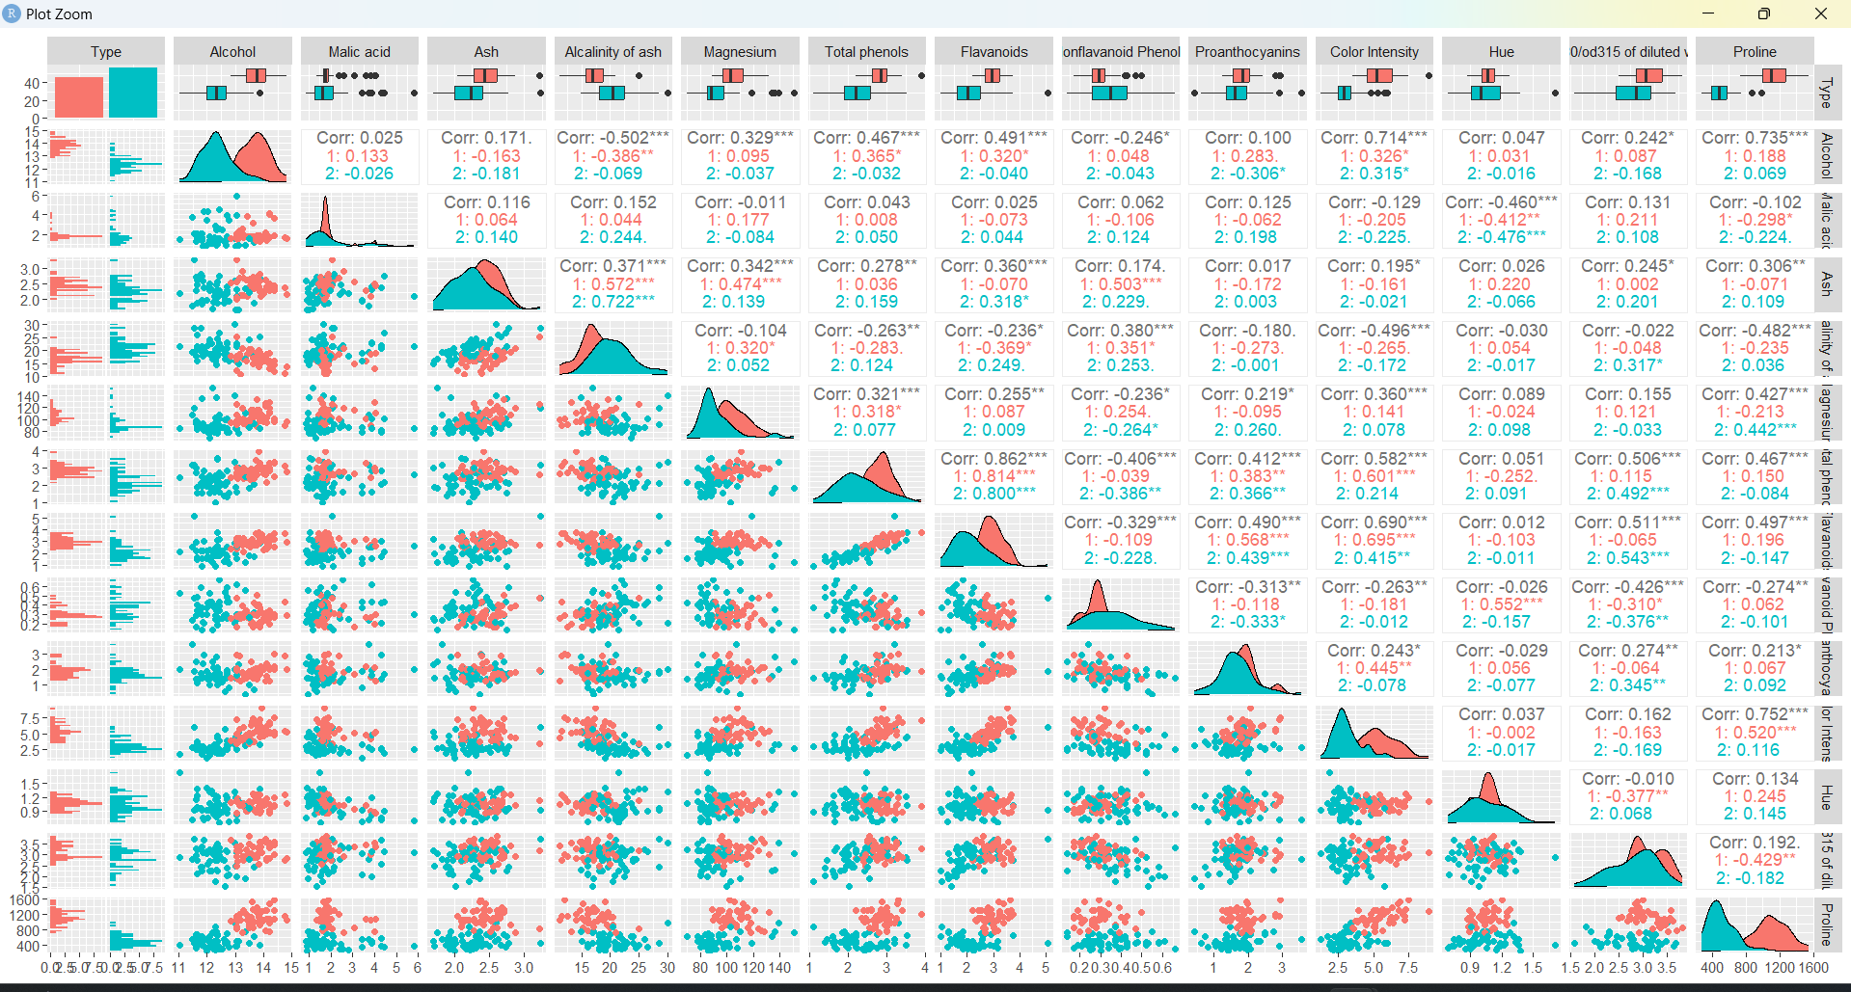
- I am choosing the relationship between Malic acid and Proline because those disparities seem the most drastic between the two wine types.
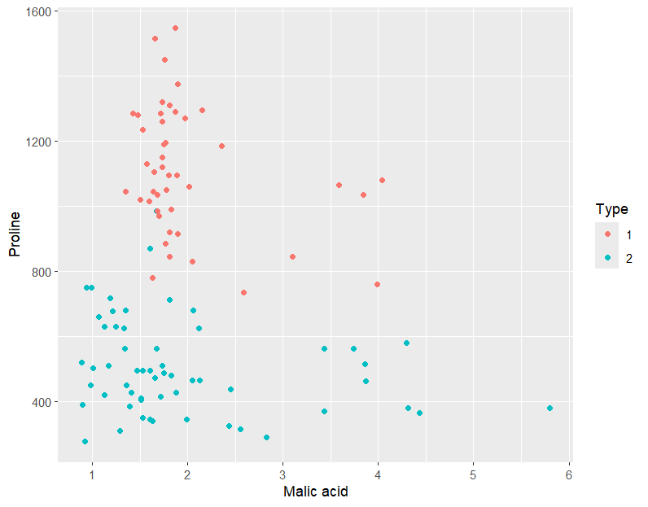
First: Linear Kernel
Call:
svm(formula = Type ~ Malic.acid + Proline, data = train,
kernel = "linear")
Parameters:
SVM-Type: C-classification
SVM-Kernel: linear
cost: 1

Number of Support Vectors: 24

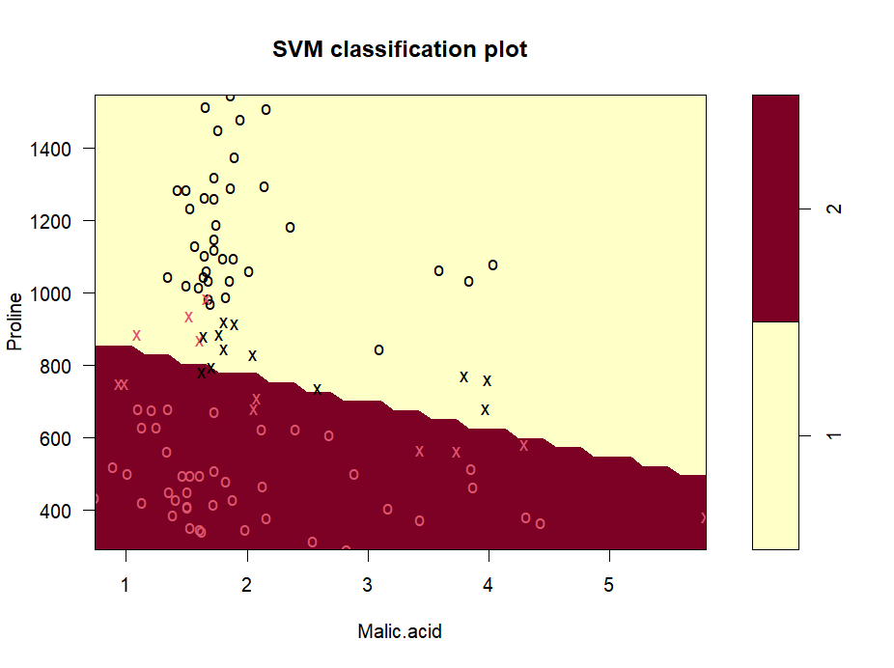
Confusion matrix
 | Predicted
Actual | 1 | 2
1 | 46 | 3
2 | 5 | 50

Accuracy: 0.9320388
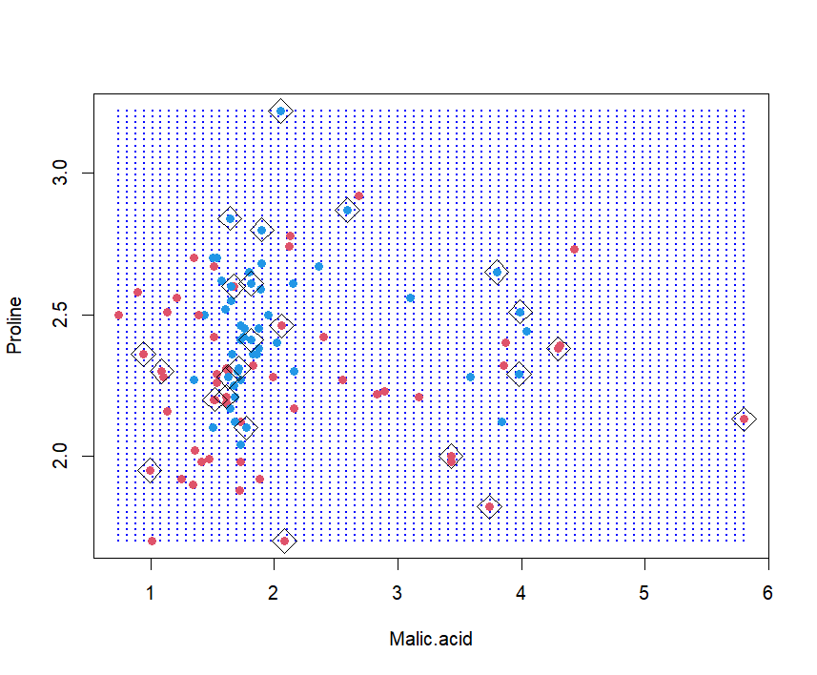
Polynomial Kernel
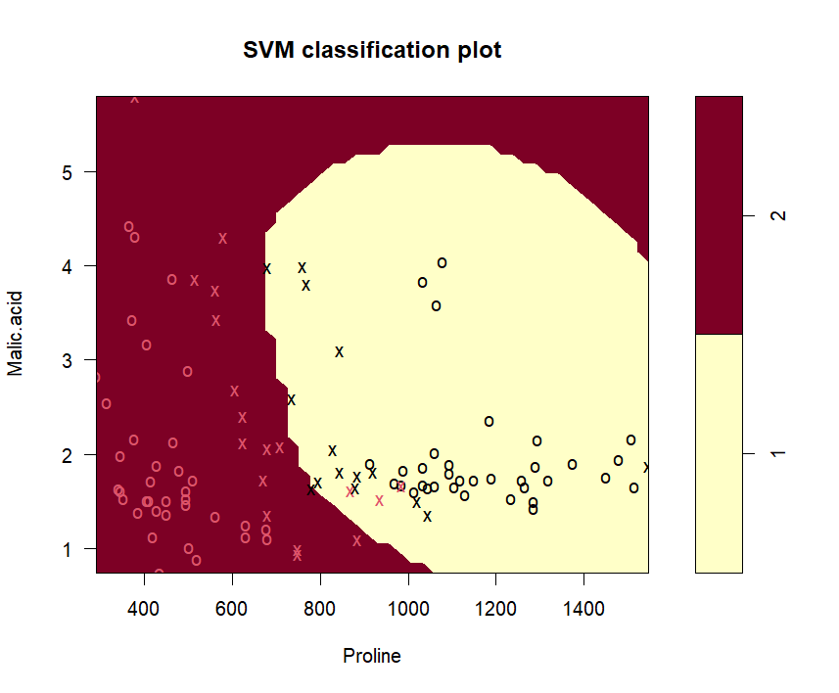
Confusion matrix
 | Predicted
Actual | 1 | 2
1 | 48 | 1
2 | 3 | 51

Accuracy: 0.961165
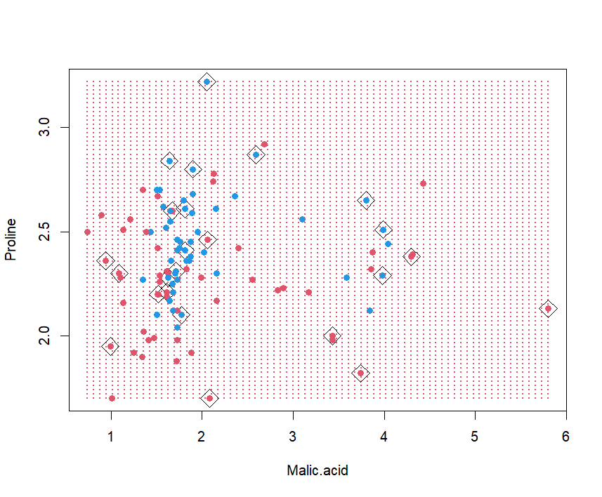
precision recall f1
1 0.9411765 0.9795918 0.9600000
2 0.9807692 0.9444444 0.9622642
Optimal C and Gamma Values
- Gamma 0,1
- Cost 1
- Best performance: 0.04545455
Call:
svm(formula = Type ~ ., data = train, kernel = "polynomial", gamma = 0.1, cost = 1)

Parameters:
SVM-Type: C-classification
SVM-Kernel: polynomial
cost: 1
degree: 3
coef.0: 0

Number of Support Vectors: 49

Confusion matrix
 | Predicted
Actual | 1 | 2
1 | 49 | 0
2 | 1 | 53

Accuracy: 0.9902913
precision recall f1
1 0.98 1.0000000 0.9898990
2 1.00 0.9814815 0.9906542
KNN Model
Confusion Matrix and Statistics

Reference
Prediction 1 2
1 17 2
2 0 20

Accuracy : 0.9487
95% CI : (0.8268, 0.9937)
No Information Rate : 0.5641
P-Value [Acc > NIR] : 9.514e-08

Kappa : 0.8971

Mcnemar's Test P-Value : 0.4795

Sensitivity : 1.0000
Specificity : 0.9091
Pos Pred Value : 0.8947
Neg Pred Value : 1.0000
Prevalence : 0.4359
Detection Rate : 0.4359
Detection Prevalence : 0.4872
Balanced Accuracy : 0.9545

'Positive' Class : 1

Confusion matrix
 | Predicted
Actual | 1 | 2
1 | 17 | 2
2 | 0 | 20

Accuracy: 94.87 %

Comparison
